Discussion Questions

I think he realized that he had been through enough adventure in his life. Tolstoy felt that he had an enough and would live a life of solitude in the country and wrote this in his book. As Chris read and finished reading the book he highlighted the passage that explained how Tolstoy felt and that gave Chris the idea it’s time to go back to civilization. He wanted to prove that civilization is like poison the wilderness is the place to be a life of adventure.
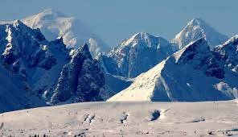
“His journal entry for the day is characteristically terse but unmistakably joyous: “CLIMB MOUNTAINS”."

“He stumbled upon the old bus beside Sushana River.”

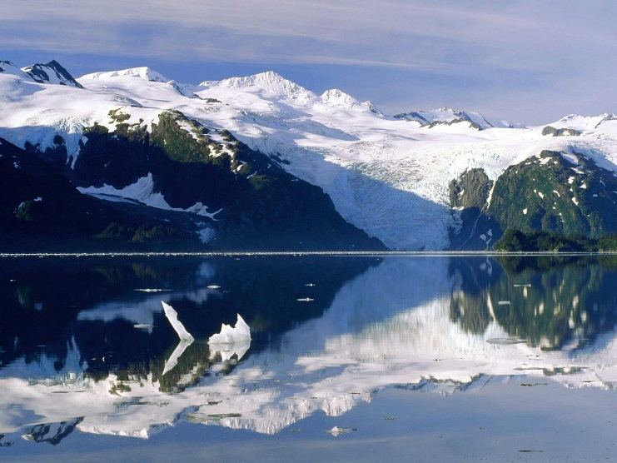
“The joy of life comes from our encounters with new experiences, and hence there is no greater joy than to have an endlessly changing horizon, for each day to have a new and different sun.”

